I

Carisbrooke castle is a 1000 year old building in Isle of Wight which housed all sorts of famous people in the royal family. Carisbrooke castle was used as King Charles the first prison due to his civil war defeat. King Charles the first also failed to escape his imprisonment in Carisbrooke castle. This incredible building has survived many battles all because of the tough walls and defences. The building used to be a Saxon fortress and a castle of the Norman Conquest, much remodelled during the Middle Ages and under Queen Elizabeth the first rule.

Did you know that the donkeys in Carisbrooke castle all their names start with a J because when Charles was planning his escape route, he always singed his letters with a J.
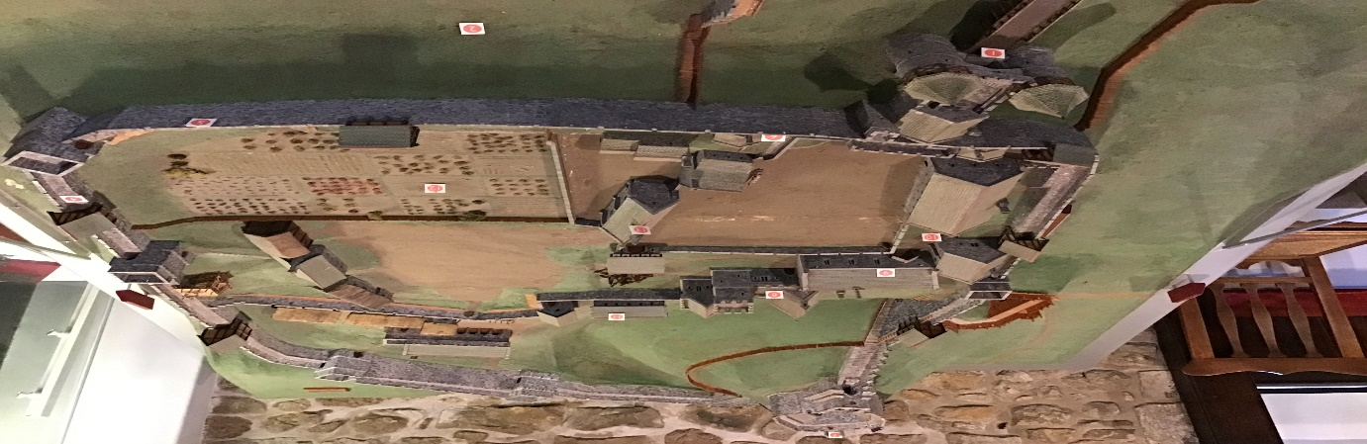
The well in Carisbrooke castle is 50 metres deep, so if you fall in there is no way you’re coming back up. Carisbrooke castle is a great fortress which began life as an Anglo-Saxon earthwork defence against Viking raids.

