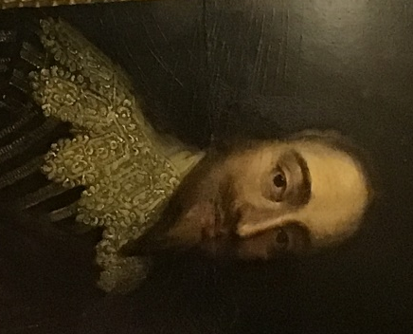
Carisbrooke Castle
Carisbrooke Castle is a historic building (built in the late roman times of about the year 1100) in the village of Carisbrooke. One of the most memorable people who lived there was King Charles the first of Scotland and England, who was imprisoned there in the proceeding of his trial and execution after the civil war. Although he was a prisoner, his facilities were not the worst.
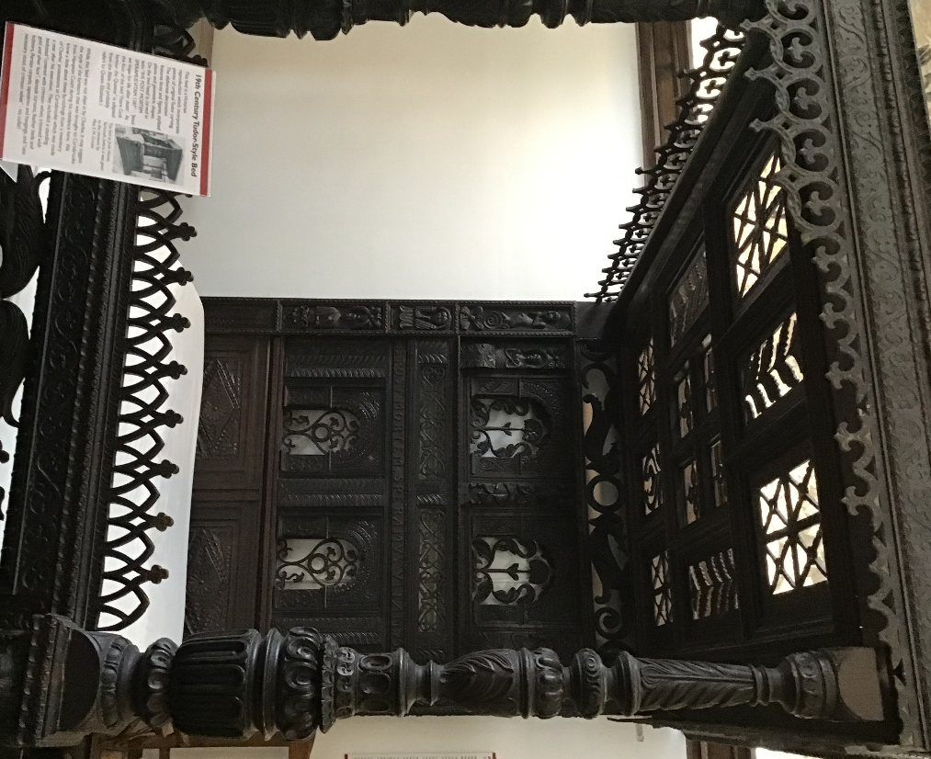
Later on, Princess Beatrice (Queen Victoria’s youngest daughter) stayed there for a summer holiday home.
Although it was built in the roman times, one of our first pieces of evidence about who stayed or lived there demonstrates the fact that the Castle was an Anglo Saxon fort to protect them from Viking raids.
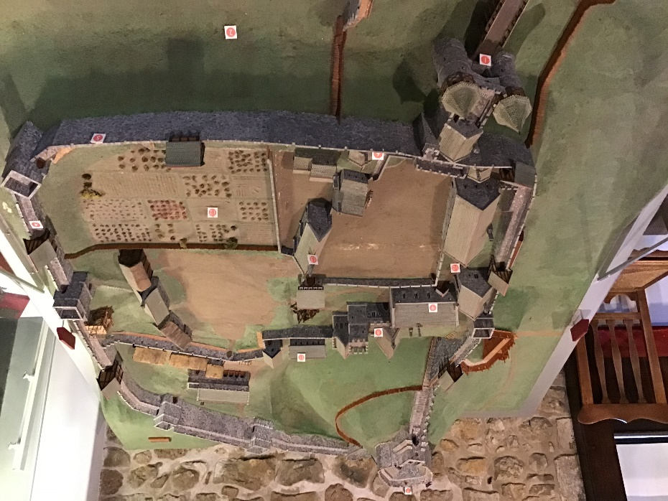
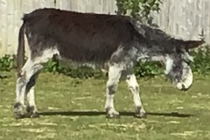
The Isle of Wight donkey sanctuary wasn’t there for ever and this is where the domestic donkeys use to live before they were taken in by the sanctuary. Although most of the donkeys are now at the sanctuary, they are still a few at the castle.
For going to the castle, I am excited to seeing the different sites and objects and learning about the history about the castle.

