Donkey Sanctuary
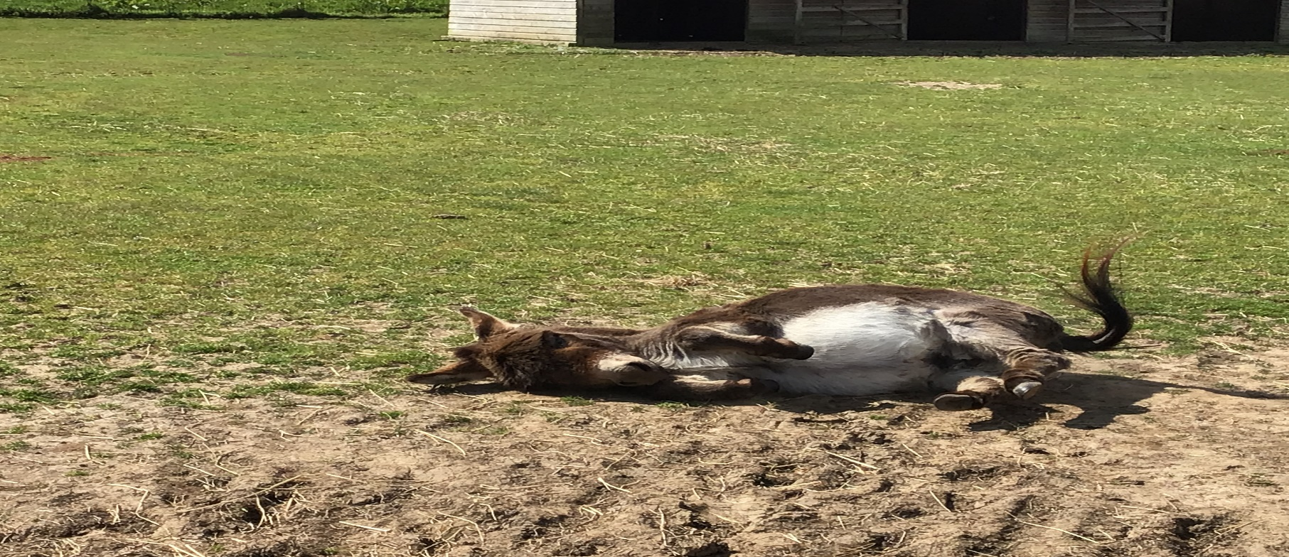
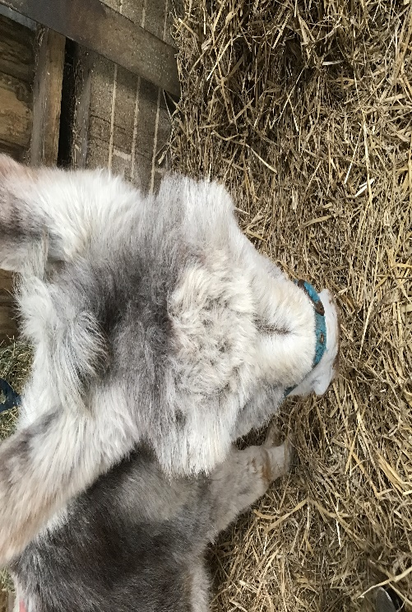
The donkey sanctuary is a country known place that schools can visit. A lot of donkeys are for to adopt. Last year the year 6s adopted Smudgy. At your time there you can feed the donkeys which can get a bit slimy. The class 6 last year
The Donkey Sanctuary is a nice place to visit as I say again. They are open all year round with wonderful staff. They are only not open on Christmas day and Boxing Day.
At the place there are only a few donkeys that are on for adoption, but they are always wonderful.

