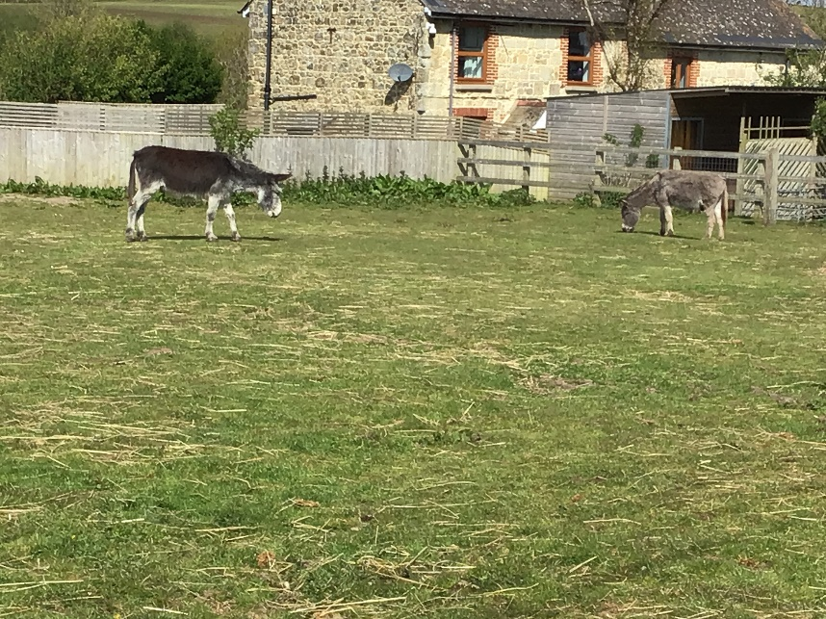
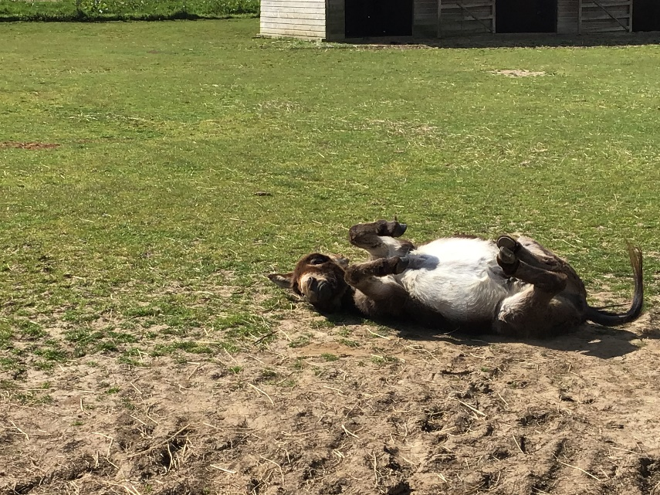
Donkey sanctuary

The actual sanctuary is in in the centre of the isle of wight. The actul donkeys live in 55 acres of land. The sanctrary covers all of the donkeys basic needs and keeps the donkeys safe. All the donkeys have a name. the donkeys are very happy there.

the donkey sanctuary was made in 1969 by a person called Elisabeth Svendsen. In 1973 it was registerd at a charity. The person who founded donkey sanctuary got the idea when she saw 7 donkeys skwished in a small pen so she made donkey sanctuary.

