Isle of Wight Donkey Sanctuary

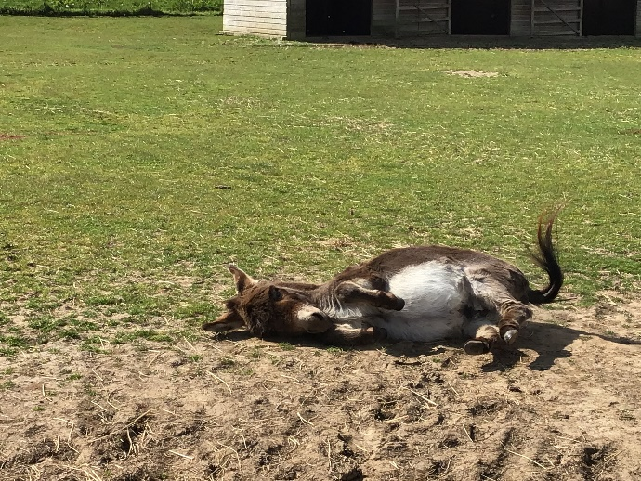
Donkeys have been on the Isle of Wight for centuries. Since 1696, donkeys have worked bringing up water from the Carisbrooke castle 150 foot well. People used to think the prisoners of the castle performed this job. All the donkeys that did this job had names beginning with J. This started because a prisoner when writing letters planning his escape always signed them as J.

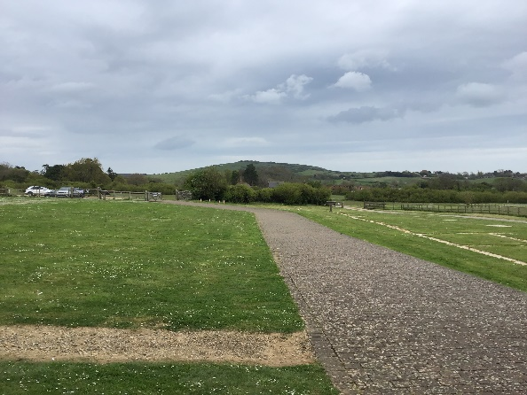
In 1987, a man called Charlie found an abandoned donkey and his wife bought some land and they rescued donkeys from then on. In 1990, they were registered as a charity. Then became a donkey sanctuary.

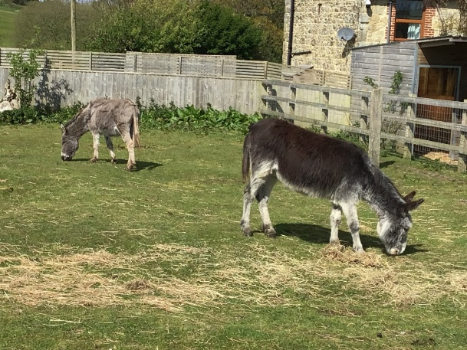
Most of the donkeys at the Isle of Wight donkey sanctuary were rescued in some way. You can adopt these donkeys (meaning you pay for their care and welfare). There are over 140 donkeys at the sanctuary but these aren’t the only furry friends they have there they have: Shetland ponies, miniature Shetland ponies, miniature donkeys and mules.

