Donkey Sanctuary:
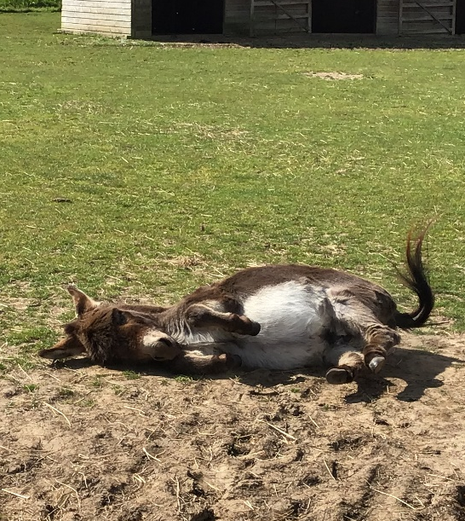
The donkey Sanctuary is somewhere where you can adopt a donkey and own it for a year. It started in 1987 and now has over 140 donkeys. They have lots of different types of animal: donkeys, miniature donkeys, ponies, Shetland ponies, miniature Shetland ponies! If you go for an experience you can feed a donkey, do poo picking (farmers did do this) and cuddle and groom the donkeys.

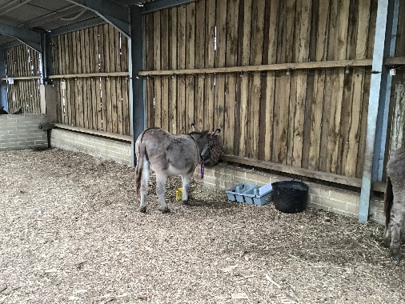
If you want to help the donkey sanctuary you can adopt a donkey or give money to them to keep people coming and enjoying the donkeys. You can also volunteer to help them look after the donkeys. If you give £5 you can get eye drops, salt lick, a roll of vet wrap and a hoof pick.

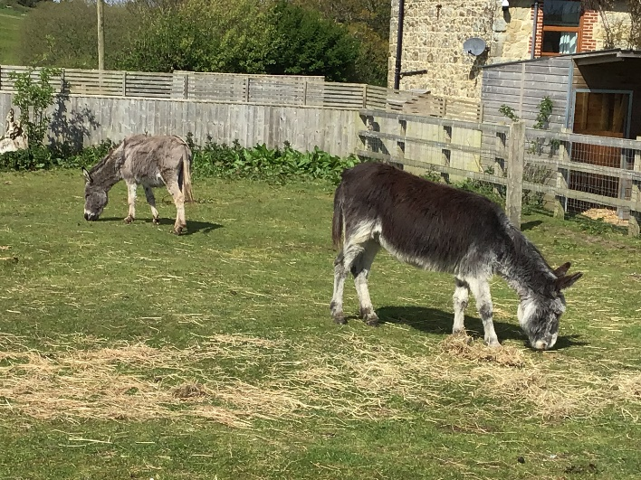
I’m looking forward to seeing the donkeys and doing activities with them. I’m also looking forward to learning about the history. I would like to see if Barnaby is an option to adopt because I really like him and he’s really cute.

