Brading Roman Villa
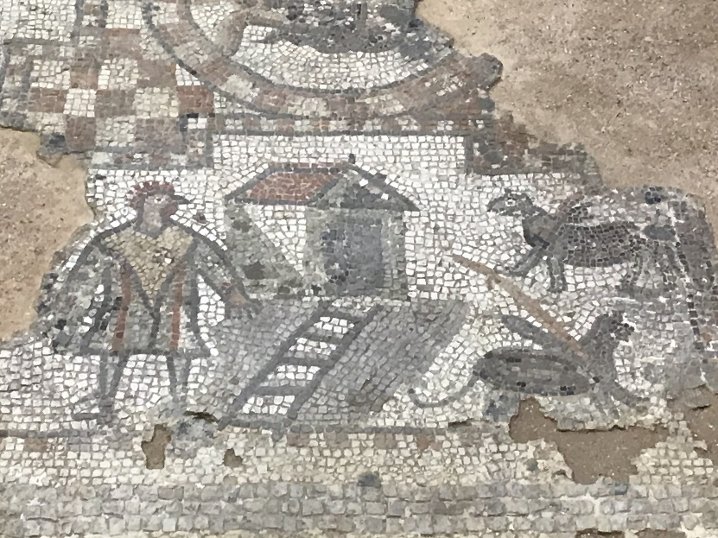
The Brading Roman Villa is located in the Isle of Wight and was built around AD 100 in the 1880’s. The Brading Roman Villa was a luxurious residence for wealthy Romans, you can tell this by the fact that there are lots of remains of mosaics left around the land. One of the most interesting mosaics left on the site was called the chicken man, because it is the only one of its kind found.
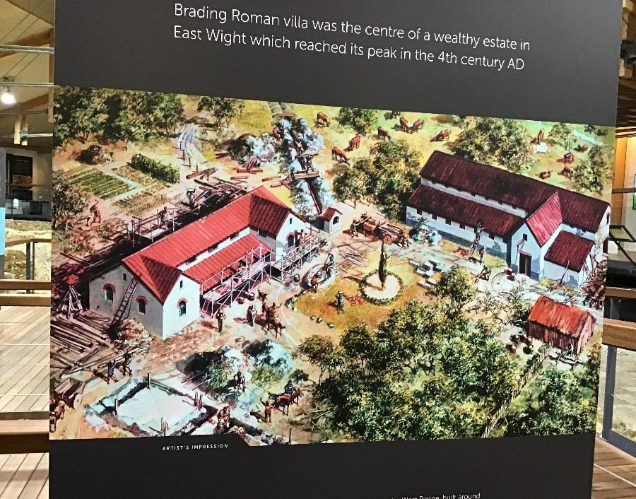
You also have an idea that it was for rich and wealthy romans because people believe that they had their own private bathrooms and usually people who lived in the roman times would have to share a public bath with strangers.
The site of the Brading Roman Villa is quite spectacular, it has many buildings and lots of land, with a beautiful view. Today, the Brading Roman Villa is a museum that you can visit and see a bit of what it would be like to stay in a villa for rich romans.
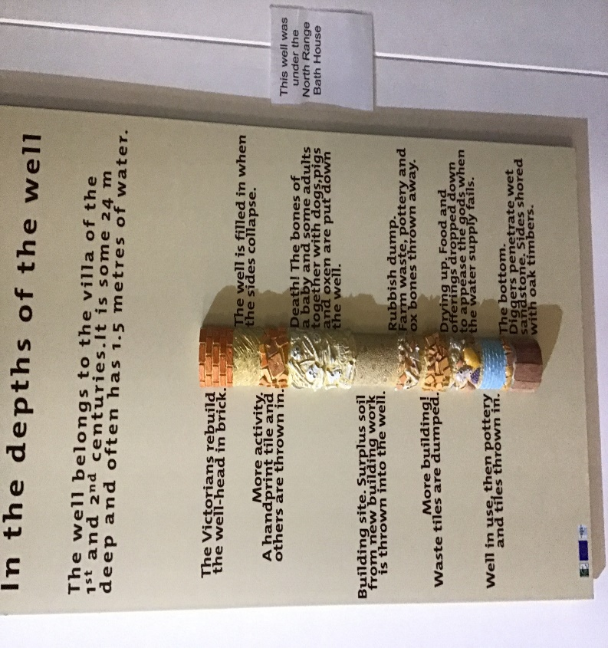
As well as having many rooms and different buildings, each with a unique style and purpose, they also had a well. Archaeologists have found bones buried at the bottom of that well underneath lots of rubbish, the bones seem to be children bones and a few animal bones too. Some people believe that the Romans tried to hide the bones at the bottom of the well, underneath the massive pile of rubbish, maybe it was a sacrifice that could be a crime!

I am very excited to go to the Isle of Wight and see the Brading Roman Villa, I am very interested in the well and why there are bones at the bottom of it. I can’t wait to see the whole site of the villa and the view surrounding it.

