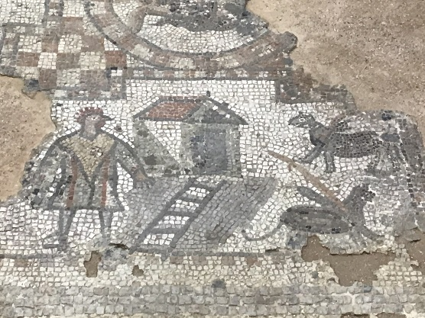
Brading Roman Villa is a historical building near the coast of the Isle of White it is approximately built in 100 AD by the romans. The Romans built the Villa when they had invaded Southern Britain and the Isle of Wight for nearly four hundred years ago.
Brading Villa is home to some of the world’s most famous mosaics ever found, including the Chicken Man which is a mosaic of a man with a chicken head and to this day it is the only mosaic ever found with the chicken man in it. When I go to the Isle of Wight I am looking forward to seeing the chicken man because there is only one of these paintings in the whole entire world and it looks very fascinating.
Fun fact most Roman Villas are symmetrical in their rooms and buildings.
Brading Villa is located in a village area near the coast, which is home to only 1906 people which is very small.
Back when Brading Villa was in use, the people who lived there were very wealthy because they had a lot of animals for food and a lot of farming land to grow crops and vegetables. They also had a room for slaves which means they had to be quite wealthy to be able to afford slaves and it was a big room so they probably had multiple slaves for multiple different jobs.
When people were trying to discover the secrets of the Roman Villa they found a well and at the bottom of the well as well as fish bones to show that they catch their own fish, there was also children’s bones down there and still to this day people still wonder who the bones belong to and why are they there.
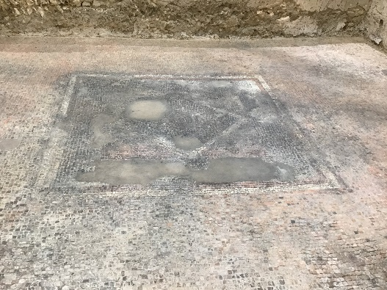
This is one of the Mosaics and it is purposely outside the house because it is saying when people walk in and see the mosaics we are rich here’s all my money on the floor and your walking on it right now. Sometimes when it rains and gets flooded the mosaics would get ruined by the water and become un-stuck and loose.
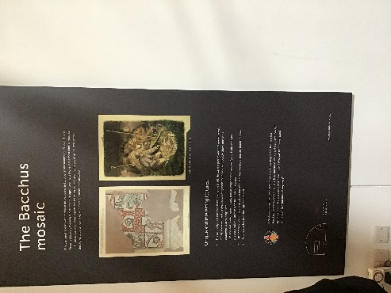
The Romans were extremely intelligent as they were the founders of heated floors by creating a furnace room which they would put a big fire in, and they sort of have lots of tunnels stacked with tiles where the heat goes through the tiles up into the floor because heat rises then it warms the whole house up and not just the floor, because heat rise through the floor as well as stays under the floor to make it warm.
They also have a mosaic of Bacchus a Roman god they would have worshipped who is half goat half man and is often to do with nature and the leaders of the wildlife.

