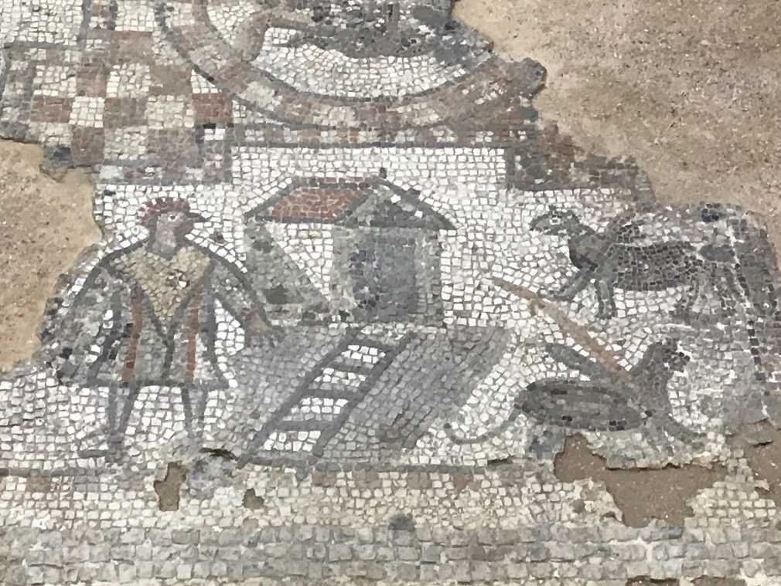
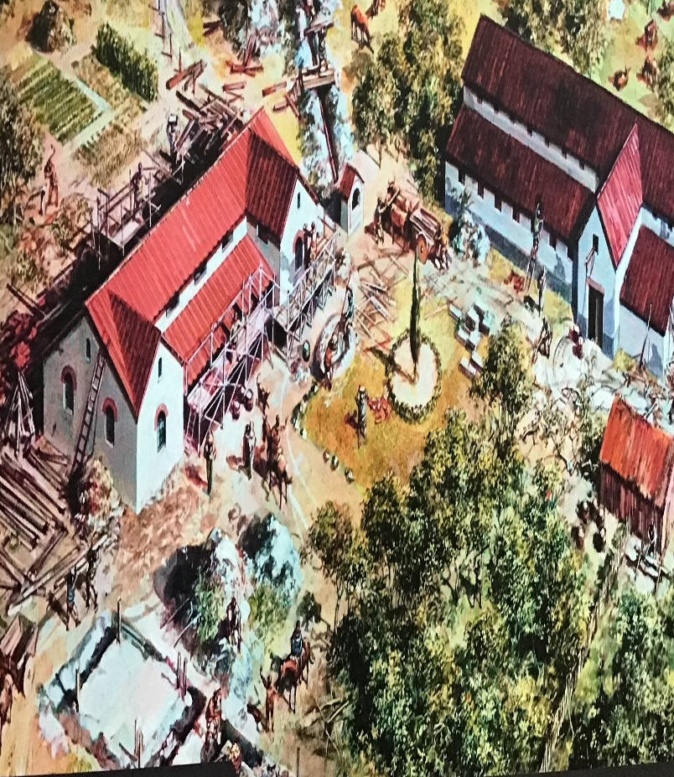
Brading Roman Villa
When we go to The Braded Roman Villa, I am looking forward to seeing all the different mosaics on the floor and trying to understand what they mean. I am also interested in the colour scheme they would have used in roman times and I want to see if I can spot anything I recognise in the mosaics.
The Brading Roman Villa was built in AD 100. Brading means the act of making a product, organisation, person or place easy to recognise as different from the others by connecting it with a particular name, design, symbol or set of qualities. Brading Roman Villa is one of the finest roman sites in the U.K. From beautifully presented mosaic floors, to an extensive collection of roman archaeology, this proves a lot about the romans. By the 4th century, the grand West Range was completed as a winged corridor villa, making up the main building of the family’s residence. Over the interior of the West Range was changed, with walls moved and mosaics added to suit the changing times and fashions. A number of neighbouring villas were situated around The Villa.

This mosaic is particularly special because it is the only known one of its type and has led many archaeologists, Roman historians and mosaic specialists to question its meaning. Mosaics date from the 3rd and 4th century AD, they tell the stories of roman myths, gods and goddesses. Many experts have tried to decipher the story of the stones, especially with some of the unique panels such as The Cockerel Headed Man. The Cockerel Headed Man is the most intriguing of all. Who is it depicting? What do the symbols around him mean?

