Brading roman villa- Isle of Wight
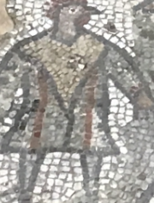
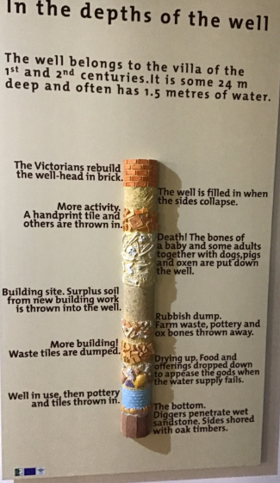
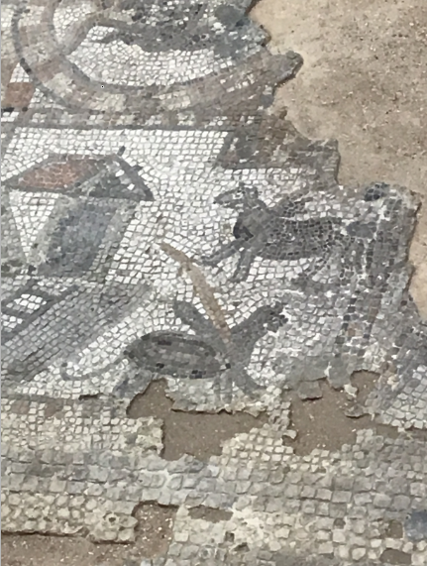
This Roman villa in the Isle of Wight was built in the years between AD 100 and 300 and was the ideal place for wealthy romans since it was easy to communicate with and travel to other island settlements, the mainland and across the channel to Gaul (France). The many mosaics on the floors were a sign to the rich guests to look at them and how wealthy they were. Many of the mosaics here are the only picture of the image in the world such as the chicken man mosaic shown below.
In Brading Roman villa, people have discovered bones of animals and children buried inside and around the wells there. Nobody knows why the people of the Brading Roman villa did this, but one of the most popular beliefs is that they used their children and animals as sacrifices to their Roman gods.
The Romans were extremely advanced for their time, they were already inventing and using things such as:
- Roman baths
- Underfloor heating
- Mosiacs to show sacred stories or to show how rich you are
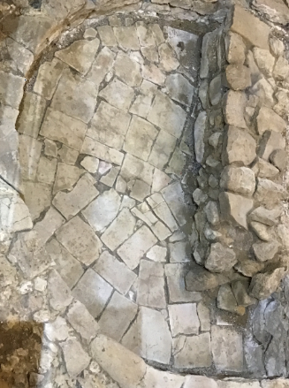
- Wells for drinking water and possibly buring sacrifices as shown above
Roman baths were another way for well-off Romans to show how rich they were; since Roman baths were relitavely new, only rich people could afford a bath in their house. The less well-off would would have to go to a local bath.
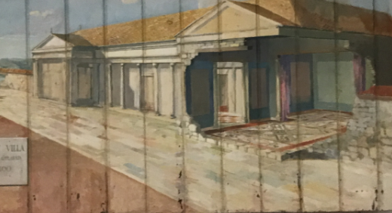
The underfloor heating was accomplished by a furnace room. The pipes from there would go under the floor and heat up the rest of the room.

