Osborne House (IOW)
Osborne House is were Queen Victoria lived in the
Victorian times in her holiday. The house is massive compared to our normal house’s at home.
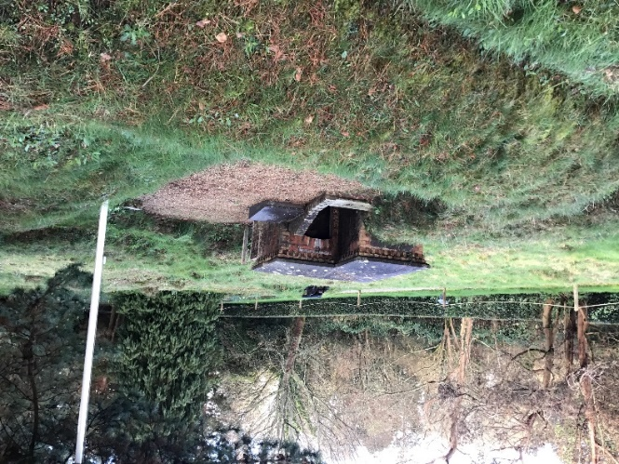
Queen Victoria had 9 kids in her family but some of them were a bit naughty.
One of the kids locked their governess in the barrack.
My question is, why did they lock there governess in the barrack?
Queen Victoria had a holiday house that looked very nice in their back garden which they would stay in for the holidays.
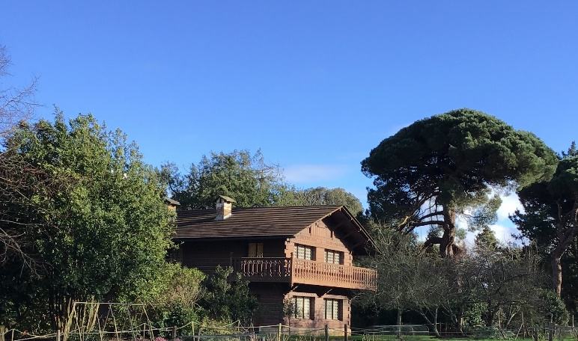
My question is, why did it look so nice on the outside?

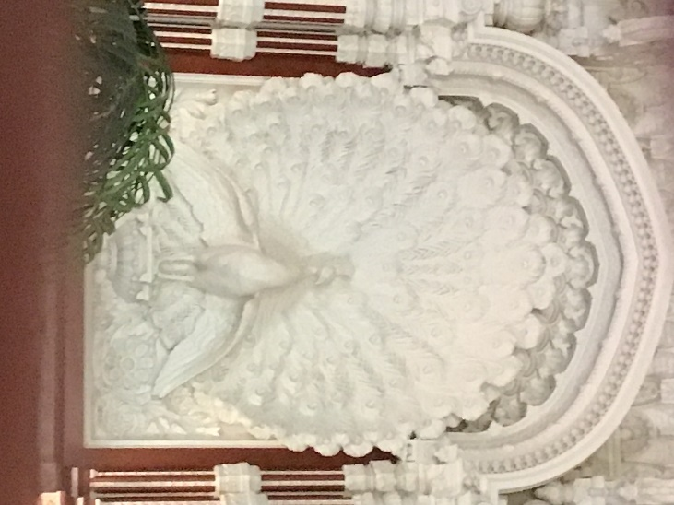
In one of the places that Queen Victoria had in her house has very carefully carved out the walls and ceilings with some humans on them and some other things on them too.
My question is, how did they do that?

