Osborne House

Osborne House is a Victorian house that Queen Victoria and Prince Albert and their kids used to spend their holidays. Osborne House was like a massive mansion built for the queen and their kids to have lots of fun and a break from their work.
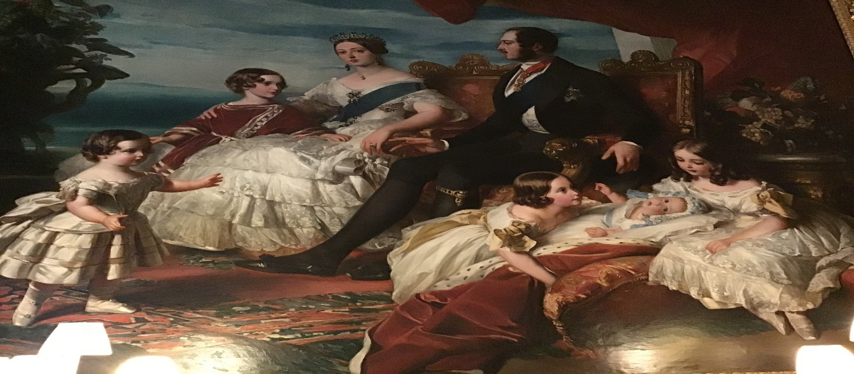 This is Queen Victoria, Prince Albert and their kids.
Queen Victoria hade 9 kids they consist of 5 girls 4 boys.

The kids had one hour of play time with their parents then they went to their playroom called Swiss cottage which is a cottage all to themselves. They also got a trench almost going through the whole of their garden, they would all be in different parts of the trench and they would pretend that they have guns, pop their heads out and try shoot each other. One time some of them did a really bad thing. There was a fort that had a meatal door and lock and some of them locked their governess in their and didn’t let her go for a while. They properly got in a lot of trouble. I would certainly never do that in my life how naughty. 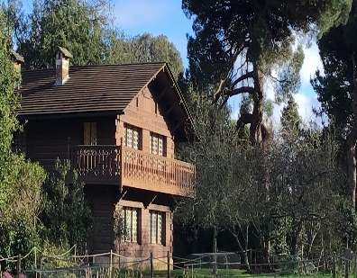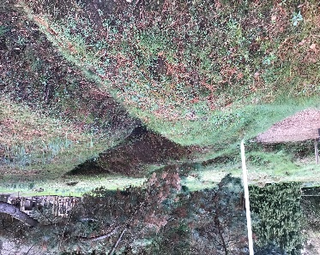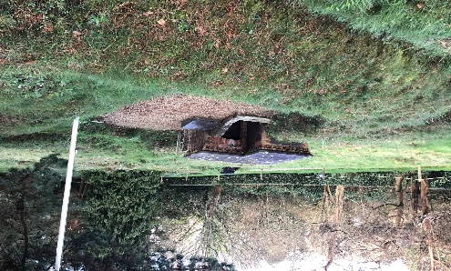 each child had their one fruit patch to grow food on.
I would like to find out how long the children locked the governess in the fort, how long they played in Swiss Cottage for as well as what games they played.

Osborne House is around 5000 ACRES!!! 5 thousand acres is absolutely massive compared to an average house. It must have been really hard to get around their in a rush right. What a massive floor plan right WOW.

