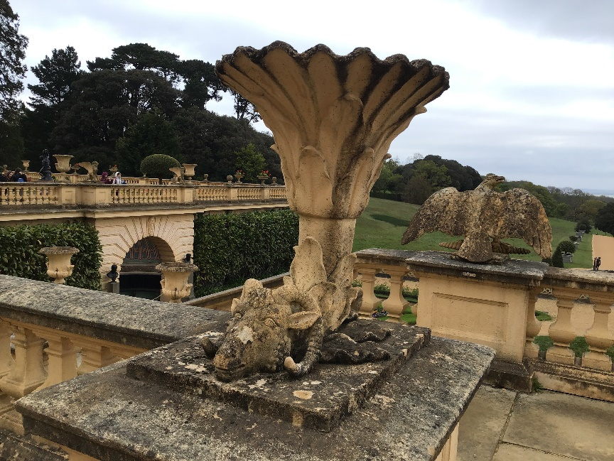
Osborne House

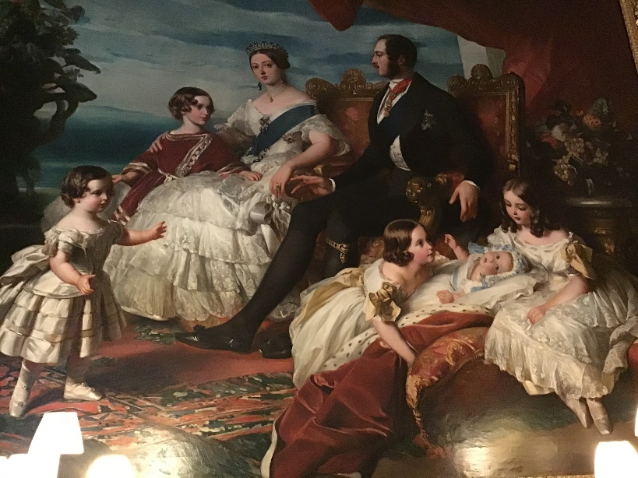
Osborne house’s owners were Queen Victoria and Prince Albert. This is where they would stay for holiday with their nine children.Sometimes the royal family come to stay there. Osborne house and its land covers around 2000 acres which is lots of land.

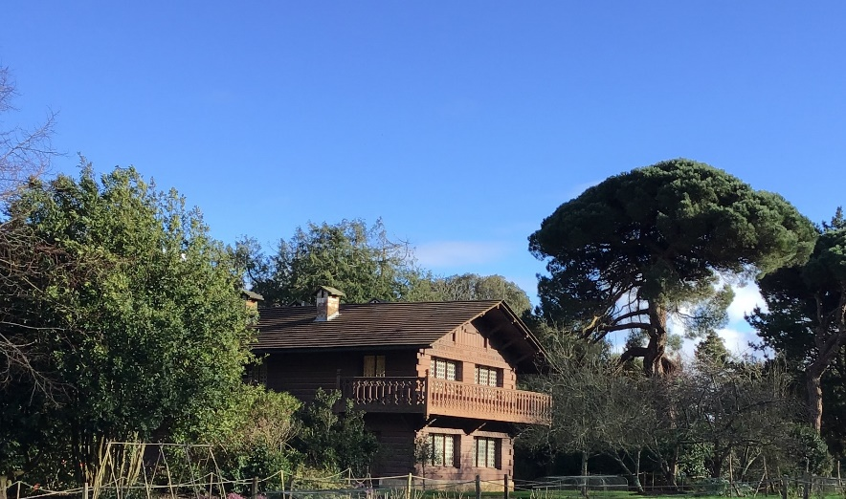
Queen victories original name was Alexandrina Victoria and did you know that she had a German mother and an English father. After Prince Albert died, on the 14 December 1861, Queen Victoria only wore black for many years.

Queen Victoria and Prince Albert had 9 children their names were Victoria, Edward, Alice, Alfred, Helena, Louise, Arthur, Leopold and Beatrice. The boys also had their own barracks they once looked their governess in there. In the picture you can see where the children played they also had their own gardening place where they would grow vegetables. I am looking forward to know more about the children and how they caused mischief.

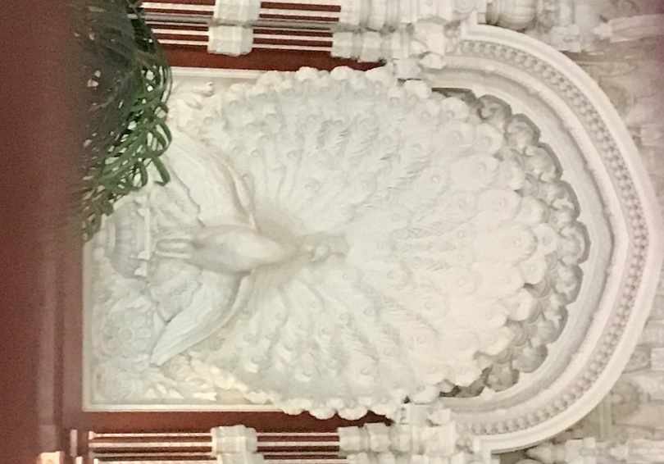
When Osborn house was built Queen Victoria had presents brought from the countries she ruled like India so there is a room covered in beautiful carvings like in the picture but the whole house is covered in beautiful things. Osborne house is almost like a palace.

