Carisbrooke Castle
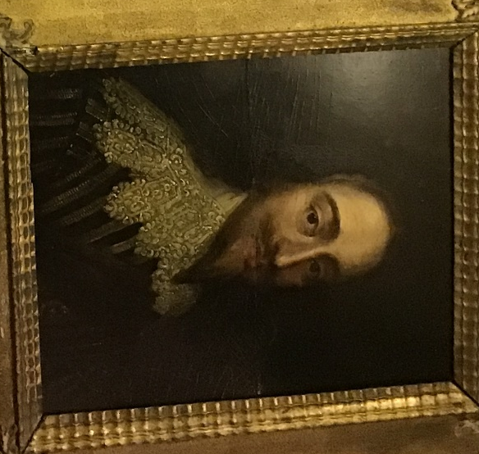
Carisbrooke castle was a prison for important royalists, and it is most famous for Charles the 1 being held prisoner there. Shortly after his arrival he was executed during the Civil war and later on in life his younger Son and Daughter were imprisoned there as well. It is also has been a central place of power and was a marvellous defence mechanism for the Isle of Wight for over 1000 years, and was well built by the Anglo Saxons and they also inhabited the Castle and was out of use in 1944.

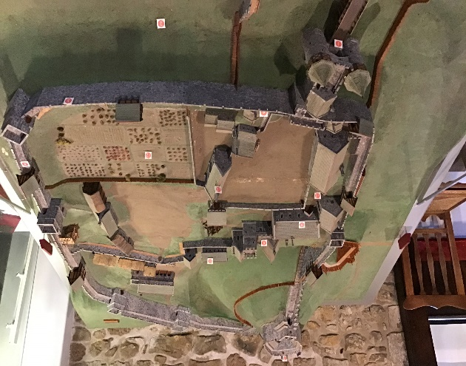
The Normans then invaded the Anglo Saxons and built over there burh and converted it into a Castle and then dug ditches within it. The Isle of Wight was now creating a powerful Lordship and who was led by Henry the 1st (reigned until 1100-35).After Henry the 1st death Matilda took over the throne and Baldwin supported her. Soon after the kings Nephew took over the throne and left it all to himself, resulting in Civil War for the unfairness that occurred.
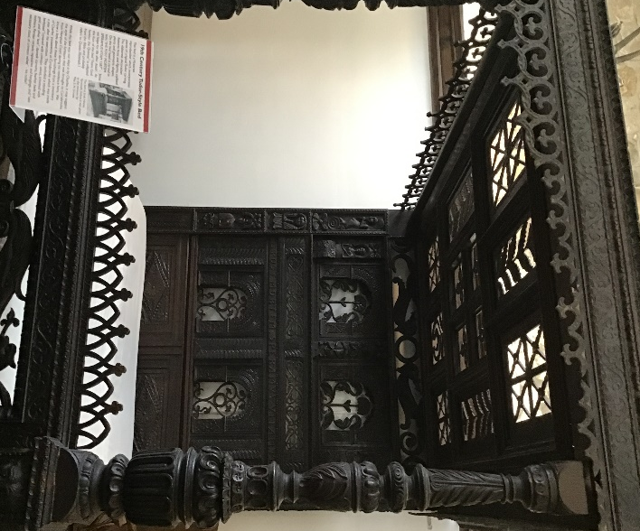
Charles was kept in the dungeon for about a year and was also put on house arrest as well.

