Carisbrooke Castle
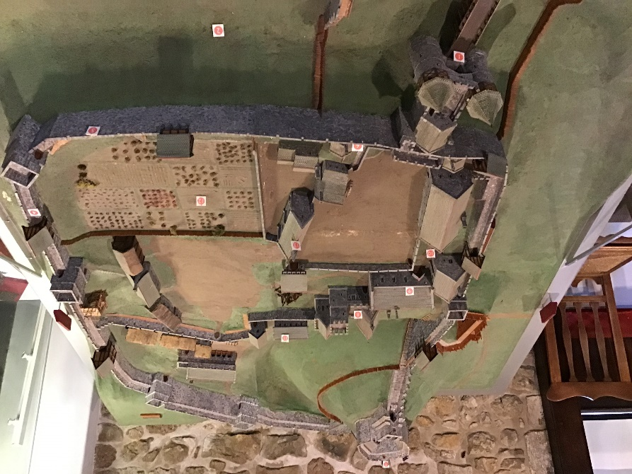
Carisbrooke Castle is a fortress that was used to be used as a defence against the Viking raids. It was built in 1100 by the Normans as a motte-and-bailey castle, until it was replaced with a more temporary castle and fortress for when the Vikings started to invade Britain. Carisbrooke Castle has been on the Isle of Wight for over 1,000 years which is quite impressive because on the Isle of Wight there is a lot of rain and bad weather that could affect the state of the castle but because it has survived so long it is clear that it was built very well and that the Normans have very good building skills. Later on, after the Vikings and England had started to have lady monarchs Queen Victoria’s daughter (Princess Beatrice) made Carisbrooke Castle her summer holiday home and the garden that you can go and see at Carisbrooke Castle was actually inspired by Princess Beatrice too. As you can see
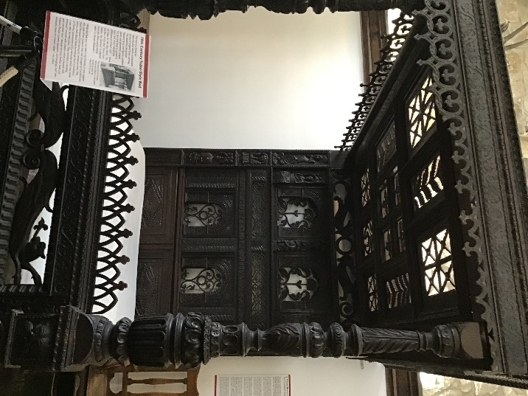
From this picture of Carisbrooke Castle back when it was built it covered a lot of land in that time but if you look at it now and compare it to more modern castles it actually looks quite small, but you also have to take in the fact that they had not discovered things about building back then and we have only discovered these tips and tricks till more recently. Because of the Civil War in 1642 Carisbrooke Castle went into the hands of Parliamentary forces and so was turned into a kind of prison that was used for more royal people then people who just came from the streets. Even so the royal people who came to the castle were treated well and got very comfortable beds and living space.
One of the few people who went to Carisbrooke Castle in the time of the civil war was King Charles the first, because he was monarch he got sent to Carisbrooke Castle instead of a normal prison in London. Later Carisbrooke Castle was also used for King Charles’s daughter and youngest son. After being sent to Carisbrooke Castle to be imprisoned there King Charles’s daughter Princess Elizabeth died there in 1650 only at the age of 14 which was very young to be sent to prison let alone dying there. Carisbrooke Castle is very well kept at the Isle of Wight and has over 131, 000 visitors each year. Carisbrooke Castle is located in the Isle of Wight in Newport which is in the centre of the country. Did you know that Carisbrooke Castle used to be home to some donkeys, they kept them there and looked after and cared for them whilst trying to look after the castle. Now you can go and see Carisbrooke Castle at the Isle of Wight and even with the huge amount of people who visit it each year it is still kept in very good condition. I am really looking forward to seeing Carisbrooke Castle when we go to visit the Isle of Wight because I am really looking forward to seeing a castle close up and all of the different parts to it. Also I am really looking forward to seeing the donkeys that they are keeping there. I think that it is amazing that Carisbrooke Castle is kept in such excellent condition. There are many different aspects and places to visit in the castle like their church. In there, there are very detailed and intricate patterns on the stain glass windows that are by the alter and all of the pews have very elaborate design that is probably hand carved into the wood. Covering the ceiling are colourful and repetitive patterns that when you look up at them will take your breath away. Also when you enter there are stone angel statues on either side that show you the entrance to the monastery.

