Carisbrooke Castle

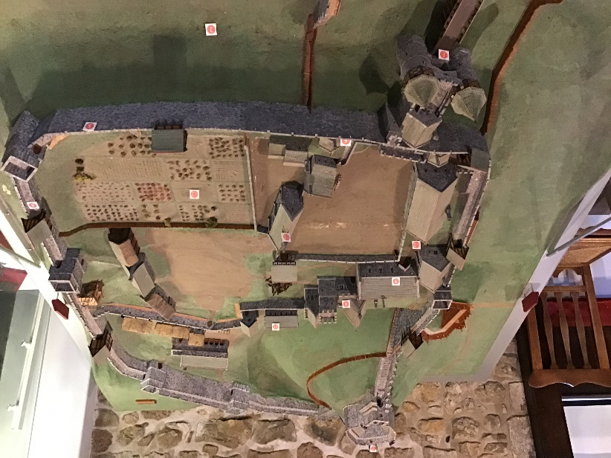
Carisbrooke Castle was built over a thousand years ago – in about 1100. It was reconstructed after the conquest of the Normans. It was renovated through the Middle Ages, then because a strong defence against the French invasion. The castle was an interesting piece of history since the Saxons protection, serving King Charles 1 in jail and a vacation home for Queen Victoria.

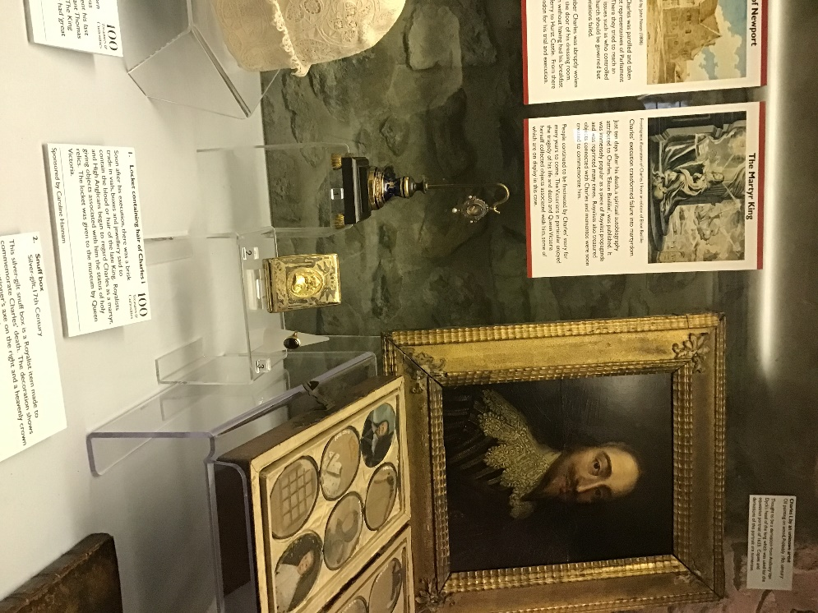
Countess Isabella de Fortibus inherited in Carisbrooke and moved into the castle. She was the richest and most powerful countess 13-century landholders in England. In the 1260s, Countess Isabella’s net wealth jumped from £1,500 to £2,500, which in these days would be adding an extra 3 zeros to the numbers. This giant house and treadwheel – which is a mechanism to raise water - were built in 1587 to get water to the castle. At first the wheel would probably have been turned by the prisoners held in the castle as a punishment. By the 1600s they changed the treadwheels routine, making it turned by donkeys for over hundreds of years. The castle held, and still does hold donkeys in the stables, still working at the treadwheel. This well is 49m deep and holds water up to 12m. Approximately, 131,000 people and visitors visit this attraction every year. It would easily take about 3-4 hours to walk around the whole castle.
I think I will enjoy finding out the history of this castle and the facts that I didn’t find out before!

